**CONTENT:-**

**Management Thinkers (Classical)** F.W. Taylor, Henry Fayol, George Elton Mayo, A. H. Maslow, Douglas McGregor

**Management Thinkers (Contemporary)** Peter F. Drucker, Michael Porter, C. K. Prahlad, Indian thinkers in management – JRD TATA, GD Birla, Ramkrishna Bajaj.

**OUTCOME:**

After studying the unit on classical and contemporary management thinkers, students can gain a comprehensive understanding of foundational management principles and modern strategic concepts. They will be equipped with insights into classical theories by thinkers like F.W. Taylor and Henry Fayol, as well as contemporary perspectives from management stalwarts such as Peter F. Drucker and Michael Porter. Additionally, exposure to Indian management thinkers like JRD Tata, GD Birla, and Ramkrishna Bajaj provides a well-rounded view. Overall, students will develop a nuanced appreciation for diverse management philosophies, enhancing their decision-making, leadership, and strategic skills in the professional world.

**MANAGEMENT THINKERS (Classical):-**

* Management thinkers in the classical school of thought are scholars and theorists whose ideas and principles laid the foundation for modern management theories.
* These thinkers were prominent during the late 19th and early 20th centuries and sought to establish systematic approaches to managing organizations.
* Classical management thinkers focused on issues such as organizational structure, efficiency, and the principles of management.
* Notable classical management thinkers include Frederick W. Taylor, Henry Fayol, and Max Weber, each contributing key concepts that shaped the understanding of management in its early stages.

1. **F.W TAYLOR ( SCIENTIFIC MANAGEMENT) :-**

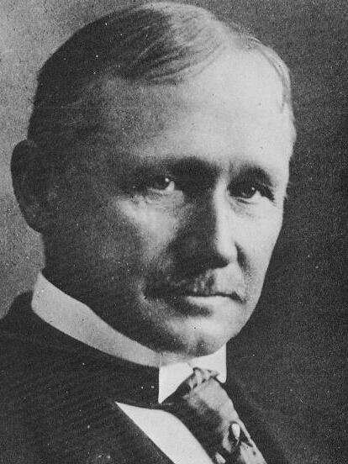

* **Frederick Winslow Taylor** (March 20, 1856 – March 21, 1915) was an American [mechanical engineer](https://en.wikipedia.org/wiki/Mechanical_engineer).
* He was widely known for his methods to improve [industrial efficiency](https://en.wikipedia.org/wiki/Industrial_efficiency).
* He was one of the first [management consultants](https://en.wikipedia.org/wiki/Management_consulting).
* In 1909, Taylor summed up his efficiency techniques in his book ***“The Principles of Scientific Management”*** in 2001.
* Taylor made his name, and was most proud of his work, in scientific management; however, he made his fortune patenting steel-process improvements.
* As a result, [scientific management](https://en.wikipedia.org/wiki/Scientific_management) is sometimes referred to as *Taylorism*.
* F.W. Taylor or Fredrick Winslow Taylor, also known as the **‘Father of scientific management’** proved with his practical theories that a scientific method can be implemented to management.
* According to Taylor, **“Scientific Management is an art of knowing exactly what you want your men to do and seeing that they do it in the best and cheapest way”**.
* Taylor gave much concentration on the supervisory level of management and performance of managers and workers at an operational level.
* Let’s discuss in detail the five principles of management by F.W Taylor.

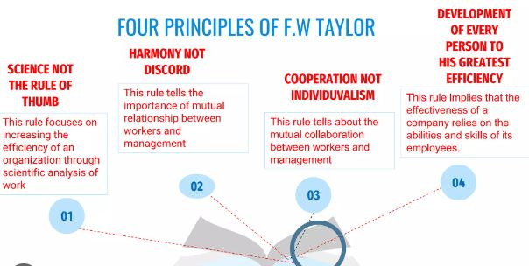

1. **Science, not the Rule of Thumb-**



* ***According to this principle,*** **there should be scientific study and analysis of each element of a job, in order to replace the old rule of thumb approach or hit & trial method.**
* According to him, there is only one best method to maximise efficiency.
* **Rule of Thumb** means the traditional method which is not based on science or exact measurement.
* **This principle encourages *“thinking before doing”***
* Taylor emphasised that manager should scientifically analyse each component of work and the motion required to perform it.
* Scientific methods are based on cause and effect, whereas, rule of thumb means absolute rule of manager in taking managerial decisions. The aim is to determine ***‘one best way’*** of performing the work.
* **For Example :-** a textile factory consists of 150 workers and there are five different units within this factory (spinning, weaving, stitching, adding buttons and embroidery). Each of these units was assigned with a specialist foreman who has knowledge and experience regarding that particular activity. There will be five specialist foremen who will be assigned with 30 workers each distributed among five business units.
* The work assigned to any employee should be observed and analyzed with respect to each element or part thereof and the time involved therein so as to decide the best way of performing that the work and to determine the standard output for same.

1. **Harmony, Not Discord-**

* ***According to this principle,*** ***there should be complete harmony and proper understanding between management and workers and they should work together for organisational goals.***
* Taylor emphasised that there should not be any disagreement or discord (conflict) between them. If any clash arises, it should be reduced to minimum.
* Taylor indicated and believed that the relationship between the workers and management should be cordial and completely harmonious.
* He believed that it would increase the workflow in an organisation. A clear understanding can bring efficiency to work and create a harmonious relationship between the two components.
* To get such harmonious relations, he stressed on ‘Mental Revolution’, i.e., *“complete change in their mental outlook”.*

Or the change in attitude of workers & management towards one another from competition to cooperation.

* According to him, an organisation can increase its productivity if it reduces disputes with the labourers. Workers should not be over-burdened with the workload, and businesses should understand their requirements.
* **FOR EXAMPLE-**
* Instead of fighting over distribution of profits, they must focus attention on increasing it. For this, workers should work hard to raise the profits and management should share the increased profits with workers.
* Workers are assigned with work by one superior (like a functional foreman). These superiors are allocated separate bureaucratic powers and can divide the particular activity into several tasks depending upon the complexity of the activity. They act as disciplinarians, mediators during disputes and review workers’ performance. Such relationship between workers and superiors is necessary as it creates harmony and avoids confusion along with conflict.
* In Japanese companies, there is complete openness between the management & workers. If all workers go to strike they wear black badge but work more than normal working hours to gain the sympathy of the management.

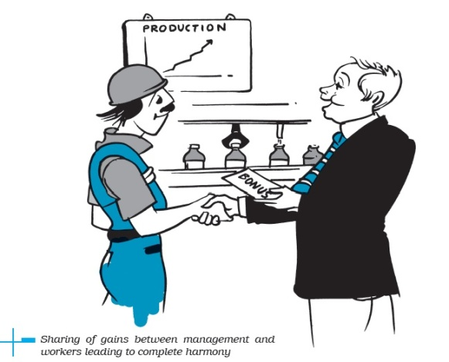

1. **Cooperation not, individualism :-**

* ***According to Taylor, there should be an almost equal division of work and responsibility between employees and management****.*
* Under the Taylor scientific management, there should be complete cooperation between the administration and its workers.
* It can result in optimum output when a business goes hand-in-hand with its employees.
* Both the managers and workers should understand each other’s requirements and work in collaboration.
* Taylor believed that an individual alone could not optimise the efficiency of work. It requires teamwork, and proper coordination between the different layers of management to increase productivity.
* This principle is an extension to ‘Harmony not discord’. Taylor emphasised the importance of cooperative group efforts for achieving

the organisational goals.

* Competition should be replaced by cooperation. Both management and workers should realise the need and importance of each other.
* Management should take workers into confidence before making any important decision. At the same time, workers should avoid strikes and unreasonable demands.
* Management should help, encourage and smooth the way for employees. This is called **“Paternalistic Style”** of management, whereby the employers take care of the needs of the employees.
* **For Example:-** Management can involve workers in determining the work standards. It will increase the involvement of workers and they will perform more efficiently.



1. **Development of workers to their greatest efficiency and Prosperity** :-

* ***According to this principle, management should aim to develop workers to their greatest efficiency and prosperity.***
* Taylor advocated the need to increase efficiency of each person.
* The principle states that any organisation’s growth depends on the skills of its workers. Thus, the scientific approach believes in proper staffing and employee training to maximise output.
* Each person should be scientifically selected & work assigned should suit his/her physical, mental and intellectual capabilit[ies.](http://http/youtu.be/dLUb62LLX9o)
* They should be given the required training to learn the ‘best method’ to do a job.
* Efficient employees would produce more and earn more. This will ensure the greatest efficiency and prosperity for both the company and workers.
* For Example :- well-built worker who can carry a certain load or weight should be given the responsibility to carry gunny bags of products into the firm. A weak-built with no experience or idea about carrying any load but relevant experience in a certain field (like accounting) is given a specific job (like an accountant) that involves minimal manual work.

**TECHNIQUES OF SCIENTIFIC MANAGEMENT:-**

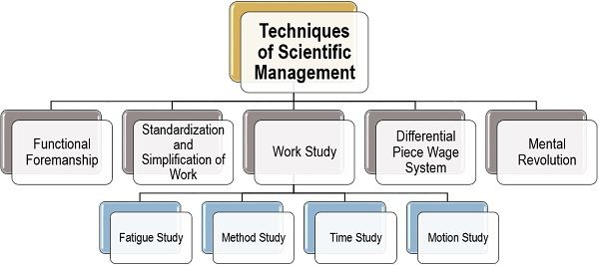

1. **Functional Foremanship:-**
   * ***According to this technique, the task of supervision is divided into several specialised functions and each function is entrusted to a specialist foreman.***
   * Functional foremanship is an extension of the principle of division of work and specialisation to the shop floor.
   * Foremen should have intelligence, education, tact, judgment, special knowledge, energy, honest and good health.
   * He knew that it is difficult for an individual to possess all these skills at a time. Therefore, he divided managerial activities into two parts, i.e., planning and production. Moreover, he suggested obtaining four clerks

under each in charge who hold expertise in their respective areas.

* + It is a technique that aims to improve the quality of supervision at shop floor by putting a worker under eight specialist foremen in the process of production.

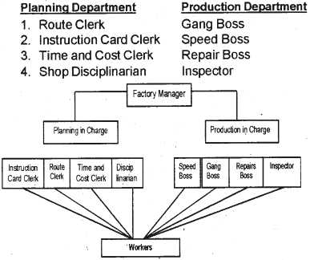

A brief description of eight functional specialists recommended by Taylor is as follows:-

**Under Planning Department-**

1. **Instruction card clerk :-**

* He is responsible & drafts instructions to the workers.
* He is expected to deal the instructions to be followed by workers in handling the job.

1. **Route clerk :-**

* He is responsible to give instructions to the workers.
* He specify the route of production.
* To lay down the sequence of operations through which the raw materials have to pass in the production process.

1. **Time and cost clerk :-**

* It lays down the standard time for completion of the work.
* He is responsible to prepare time and cost sheets.

1. **Disciplinarian** :-

* He maintains proper discipline in the factory.
* He is responsible to maintain discipline among workers.

**Under Production Department –**

1. **Speed boss :-**

* He supervises matters relating to the speed of work.
* He is responsible for timely completion of job.

1. **Gang boss** **:-**

* He is responsible for keeping machines and tools ready for work.
* He arranges material, machine, tool, etc. for operation.

1. **Repair boss :-**

* He ensures repairs and maintenance of the tools and machines with a proper working condition.

1. **Inspector :-**

* He checks & responsible for the quality of work.

1. **Standardisation and simplification of work :-**
   * **Standardisation of work** refers to the process of setting standards for every phase of business operations.
   * These standards should act as the benchmarks during production. Similarly, the working conditions, i.e. temperature, lighting, ventilation, humidity, etc. Should be standardised.
   * **For example :-** Standard time can be fixed to produce a given level of output. If workers take more time than the standard time, then corrective measures should be taken to check it.
   * **Simplification refers to eliminating unnecessary varieties, sizes and grades of the product manufactured by the organisation.**
   * It aims to eliminate unnecessary diversity of products, sizes, & types.
   * **For example :-** Hindustan Unilever Limited reduced its varieties of soaps and it generated efficient and effective results for the company.
2. **Work study:-**

* It refers to scientific study of any work.
* Scientific management requires deep analysis of all the activities performed in an organisation with the aim of producing the maximum possible output with the minimum possible efforts.
* In his effort to do so, FW Taylor conducted a number of experiments in various areas of production, like- method study, motion study, time study and fatigue study.

1. **Method study :-**

* **This technique of scientific management is conducted to find out the *‘one best method or way’* of performing a particular task.**
* The objective of this study is to minimise the cost of production and maximise the quality and satisfaction of the customer.
* **For example** :- Raw materials should be stored near place of production to avoid unnecessary wastage of time & money in transporting goods to the place of production.

1. **Motion study** **:-**

* Motion study refers to making deep analysis of various motions being performed by a worker while he is doing a particular job.
* The objective of motion study is to eliminate unproductive movements in doing a task to achieve efficiency and reduce the time required to do the task.
* Taylor used stopwatches and various colours and symbols to identify productive and unproductive movements of the employees.
* **For example:-** It is observed through motion study that worker has to move frequently for taking tool box, then such unnecessary movements can be determined by keeping the tool box near the worker. It will not only increase the productivity but also the efficiency level

1. **Time study :-**

* **It refers to a technique, which is used to determine the standard time taken by a workman of reasonable skills and ability to perform a well defined job.**
* It determines the standard time taken to perform a well-defined job.
* It helps to determine how much work an employee should be able to do in a given period of time.
* 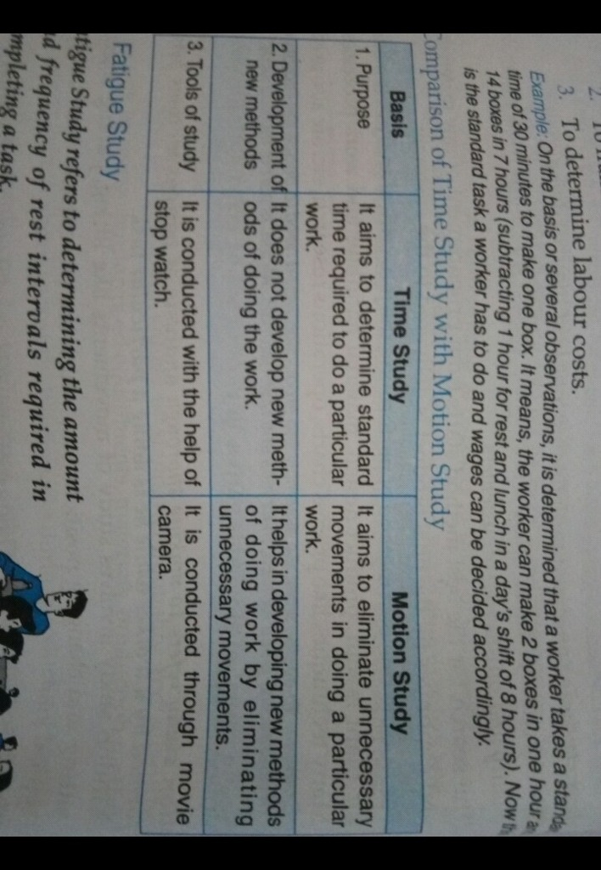It also helps in determining a fair day’s work for the workman and determining incentive schemes and labour cost.

1. **Fatigue Study :-**

* **Fatigue study refers to determining the amount & frequency of rest intervals required in completing a task.**
* **Fatigue** means tiredness from physical or mental work.
* Taylor suggested that a person gets tired when he works continuously without a break. So, he must be provided a brief rest interval in between so as to enable him to regain lost stamina.
* The objective of this study is to find out how long a person can perform the standard task without any adverse effects on his health and productivity.

1. **Differential piece wage system :-**

* **Differential piece wage refers to a system in which efficient & inefficient workers are paid at different rates.**
* Under this system of wage payment, wages are paid on the basis of work done.
* According to him, higher rates were given to the workers who are producing standard products or more and lower rates were given to those who are producing less.

1. **Mental Revolution :-**

* **It involves change in the attitude of workers and management.**
* Both should realise the importance of the other and should cooperate with each other. Both should aim to increase the size of surplus & both the parties should realise each other’s importance and work towards the profit of the firm.
* Managers should share their gains with workers, while workers should contribute to increase profits.
* This attitude will bring prosperity to both, the company as well as the workers.

1. **HENRY FAYOL (PRINCIPLES OF MANAGEMENT) :-**

* Henry Fayol, also known as the ***‘father of modern management theory’*** gave a new perception of the concept of management.
* He introduced a general theory that can be applied to all levels of management and every department.
* Fayol theory is practised by the managers to organize and regulate the internal activities of an organization. He concentrated on accomplishing managerial efficiency.
* The fourteen principles of management created by Henri Fayol are explained below.

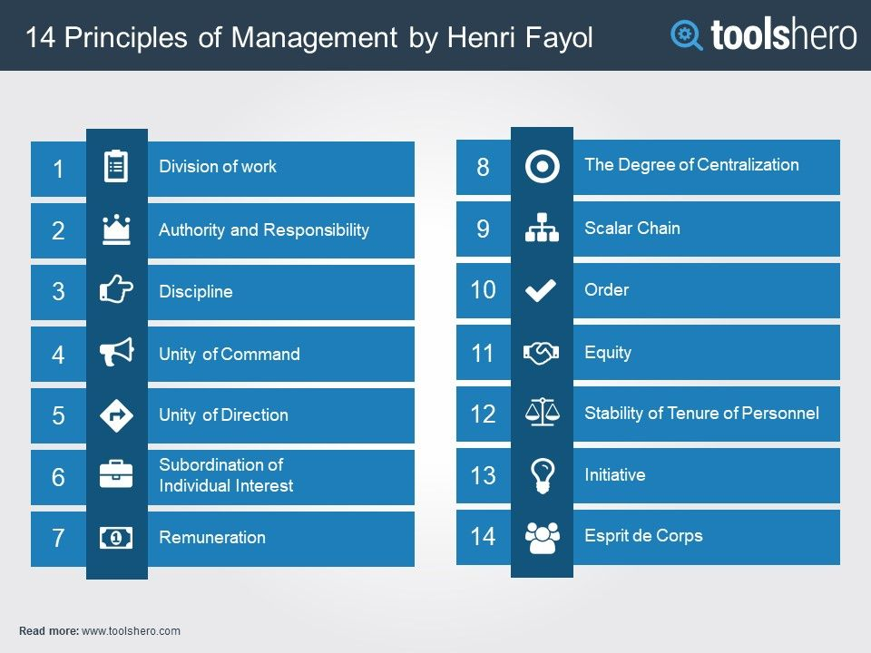

1. **Division of Work :-**
   * **Division of work refers to dividing the work into compact jobs and allocating these compact jobs to different individuals.**
   * According to this principle, work should be divided into small specialised tasks; each performed by a specialist or trained employees.
   * **For example**, in a manufacturing setting, division of work might mean that one worker is responsible for assembling parts, another worker is responsible for testing the finished product, and another worker is responsible for packaging the product. This division of labour allows each worker to focus on their specific task, reducing the amount of time and resources required to complete the overall process.
2. 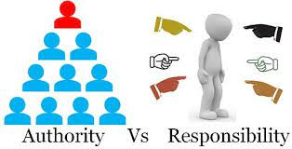**Authority and responsibility:-**

* These are the two key aspects of management.
* **Authority means the right to give orders and obtain obedience**. Authority facilitates the management to work efficiently, and
* **Responsibility means obligations to perform the job assigned on time.** Responsibility makes them responsible for the work done under their guidance or leadership.
* Authority and responsibility should be clearly defined and aligned to ensure that decisions are made and tasks are completed efficiently.
* Fayol suggested that there should be a balance between authority & responsibility.
* Giving authority without fixing responsibility may lead to irresponsible use of authority. So, an organisation should build safeguards against abuse of management power.
* **For example**, A manager at a retail store. The manager has the authority to make decisions about employee schedules, merchandise ordering, and customer service policies. With this authority, the manager also has the responsibility to ensure that the store runs efficiently and effectively, that employees are properly trained and schedules, that customer service is excellent, and that the store's financial performance is strong.
* If the store experiences any problems, such as a decline in sales or customer complaints, the manager is responsible for identifying the cause and taking action to correct it. This might involve re-training employees, adjusting store policies, or making changes to the merchandise mix.
* In this scenario, the clear definition of authority and responsibility allows the manager to make decisions and take action without hesitation, while also ensuring that they are held accountable for the outcomes of those decisions and actions. This helps to create a structure in which decisions are made and actions are taken efficiently and effectively, ultimately leading to better performance and results for the store.

1. **Discipline:-**

* In the context of management, discipline means obedience to organisational rules and employment agreement, which are necessary for the working of the organisation.
* The principle of discipline refers to the idea that individuals within an organization should follow a set of rules and standards in order to maintain order and achieve common goals.
* This principle is often used in a business or organizational context to ensure that everyone is working towards the same goals and objectives, and that everyone is held accountable for their actions.
* **For example**, a company might have a policy of punctuality, and employees who arrive late might face consequences such as a warning or loss of pay. On the other hand, employees who consistently arrive on time might receive recognition or bonuses.

1. 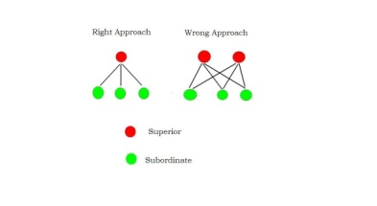**Unity of command:-**

* **This means an employee should have only one boss and follow his command.** If an employee has to follow more than one boss, there begins a conflict of interest and can create confusion.
* This also means that each employee should receive orders from only one superior.
* This helps to ensure that everyone is working towards the same goals and objectives, and that everyone is clear about their role and responsibilities.
* **For example,** a small business with several departments, such as sales, marketing, and finance. In this scenario, each department might have a manager who is responsible for the department's operations, and who reports directly to the CEO of the company.
* In this case, each employee within a department would receive instructions from only their department manager, and would not be subject to conflicting instructions from multiple superiors. This helps to ensure that everyone is working together effectively, and that decisions are made in a clear and efficient manner.



1. **Unity of direction:-**

* This principle implies that there should be ***“ONE HEAD AND ONE PLAN”*** for a group of activities having the same objective.
* All activities should be directed towards a common goal.
* **For example**, if you have a range of marketing activities such as advertising, budgeting, sales promotion, etc., there should be one manager using one plan for all the marketing activities. The different activities can be broken down for different sub-managers, but they should all work towards a common goal under the direction of one main person in charge of the whole thing.

1. 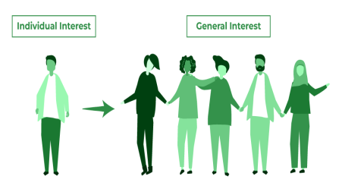**Subordination of individual interests to the general interest:-**

* According to**, this principle, the interest of the organisation as a whole must be given priority over the interest of the individual employees, in case of conflict between them.**
* The interests of the organization should take precedence over individual interests.



1. **Remuneration:-**

* This plays an important role in motivating the workers of a company. Remuneration can be monetary or non-monetary.
* However, it should be according to an individual’s efforts they have made.

1. 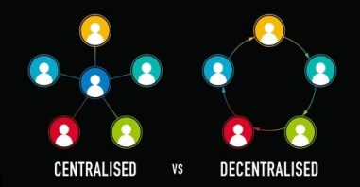**Centralization & Decentralisation:-**

* The concentration of decision-making authority by top management is called **Centralisation.**
* On the other hand, if decision-making authority is shared with lower level, it is called **Decentralisation.**
* In any company, the management or any authority responsible for the decision-making process should be neutral.
* However, this depends on the size of an organization.
* Henri Fayol says that an organisation should have a balance between complete **Centralisation** & **Decentralisation.**

1. 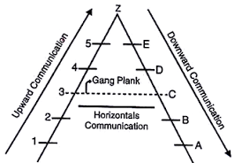**Scalar chain:-**

* Fayol on this principle highlights that the hierarchy steps should be from the top to the lowest.
* This is necessary so that every employee knows their immediate senior also they should be able to contact any, if needed.
* According to fayol, ‘organisations should have a chain of authority and communication that runs from Top to bottom & should be followed by managers and subordinates.

1. **Order:-**

* According to Fayol, **‘order’** means***- “a place for everything (everyone) and everything (everyone) in its his/her place.”***This principle means that a company should maintain a well-defined work order to have a favourable work culture.
* The positive atmosphere in the workplace will boost more positive productivity.
* Materials and equipment should be stored in an organized manner.
* This principle states that there should be an orderly placement of resources (manpower, money, materials, etc.) in the right place at the right time.

1. **Equity:-**

* The principle of “Equity” implies that similar treatment is assured to employees in similar positions.
* **For example**, workers performing similar jobs should be paid the same wage rate.
* This principle emphasises on kindness and justice in the behaviour of managers towards workers.  This creates loyalty and devotion among the employees towards the organization they work for.

1. ** Stability of Tenure of Personnel:-**

* Fayol argues that it is essential to ensure that employees last a long time in their positions.
* This means providing job security to employees.
* An employee delivers the best if they feel secure in their job. It is the duty of the management to offer job security to their employees.
* This principle is based on the idea that employees who feel secure in their jobs are more likely to be productive, motivated, and committed to the organization.

1. 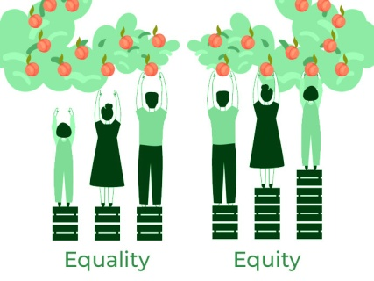**Initiative:-**

* This principle states that all employees should be encouraged to show initiative.
* It will help them to increase their interest and make then worth.
* This principle encourages employees to take initiative and be innovative.
* **For example**, workers doing similar jobs in the same organization should be paid same wages irrespective of their sex, caste, religion and language.

1. **Esprit de corps:-**

* According to this principle, management should take reasonable steps to develop a sense of belongingness and a feeling of team spirit amongst employees.
* In order to achieve the best possible result, individual and group efforts need to be integrated.
* A manager should replace ***‘I’ with ‘We’*** in his conversations to bring a team spirit among the employees.

1. **GEORGE ELTON MAYO**

* George Elton Mayo was an Australian professor of industrial relations who taught at Harvard Business School in the 1920s.
* Mayo is considered the founder of the human relations (HR) movement and his contributions to the field have earned him the titles of ***“father of HR” and “father of scientific management.”***.
* Mayo’s management theories grew from his observations of employee productivity levels under varying environmental conditions.
* His experiments drew a number of conclusions about the real source of employee motivation, laying the groundwork for later approaches to team building and group dynamics.
* Mayo’s management theory states that employees are motivated far more by relational factors such as attention and camaraderie than by monetary rewards or environmental factors, such as lighting, humidity and more.
* Mayo developed a matrix to illustrate the likelihood that a given[**team would be successful**](https://www.business.com/articles/5-reasons-why-teamwork-is-crucial-to-workplace-success/).
* His matrix demonstrates the role that varying combinations of group norms and group cohesiveness/harmony/peace play in team effectiveness.
* Mayo’s theories identify a “norm” through the degree to which a group encourages positive or negative behaviours.
* This is typically expressed through an employee handbook or workplace policies and can include formal or informal rules.
* Group cohesiveness is how a group cooperates together, defined as a group’s overall community or level of teamwork.

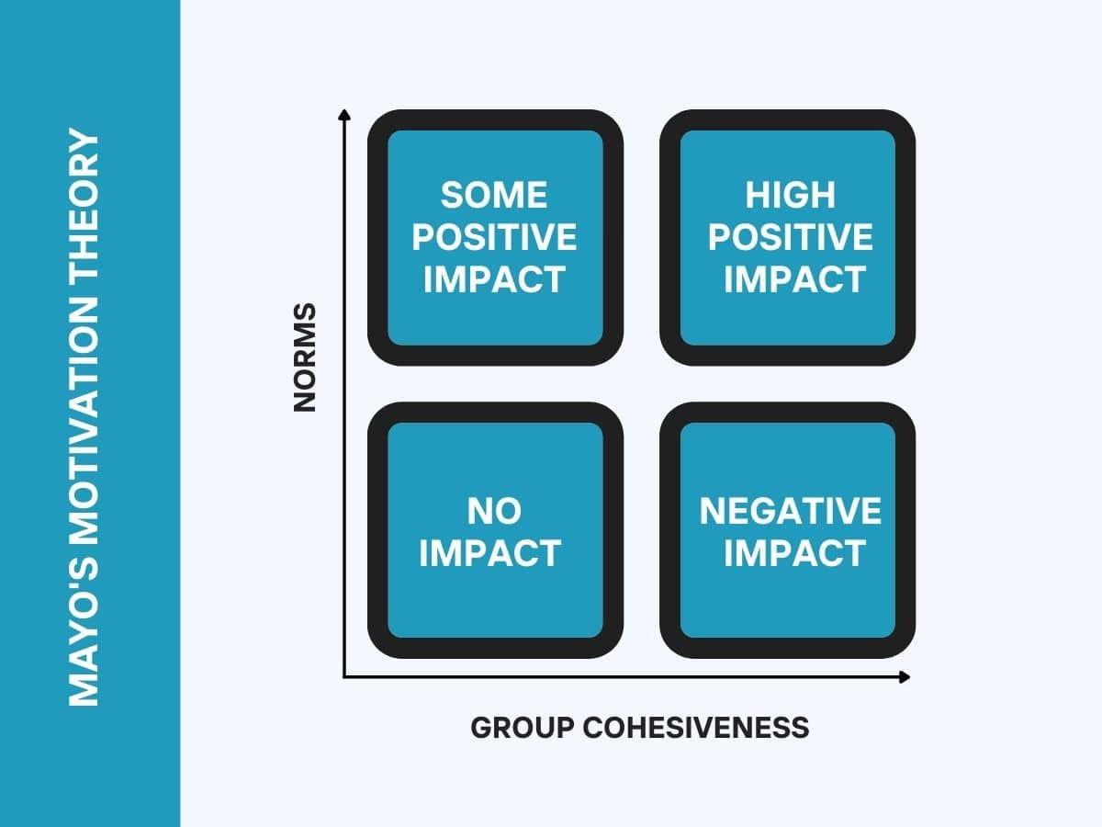

* There are four positions in the matrix:

1. **Groups with low cohesiveness and low norms:-**

* These groups are simply ineffective in terms of productivity. A team like this wouldn’t last very long.
* This is because nobody would be motivated to be productive in any way.
* This group is ineffective and has a minimal impact since none of the members are motivated to excel.

1. **Groups with high cohesiveness and low norms:-**

* These types of teams have a negative impact on productivity.
* Here the team gets on great, but negative behaviors are encouraged rather than positive ones.
* This group has a negative impact since fellow members encourage negative behavior.
* In a typical workplace, an example would be a group that gossips together and actively fights against management
* Gangs are often cited as examples of this type of group.

1. **Groups with high norms but low cohesiveness:-**

* This type of team can have a limited positive impact on productivity.
* This is because each team member will be working towards their own success rather than that of the team.
* If one team member does something great, then good for them, but it doesn’t really improve the productivity of the rest of the team.

1. **Groups with high norms and high cohesiveness:-**

* These are the teams that can make the greatest positive impact on productivity.
* In this type of team, each team member supports each other to succeed.
* People are personally committed to their success and also to the team’s success.
* A strong support network forms within this type of team.

1. **A.H. MASLOW**

* Abraham Harold Maslow was an **American psychologist** who created Maslow's hierarchy of needs, a theory of psychological health predicated on fulfilling innate human needs in priority, culminating in self-actualization.
* [Abraham Maslow](https://www.verywellmind.com/biography-of-abraham-maslow-1908-1970-2795524) first introduced the concept of a hierarchy of needs in his 1943 paper, titled ***"A Theory of Human Motivation,"*** and again in his subsequent book, ***"Motivation and Personality."***
* This hierarchy suggests that people are motivated to fulfill basic needs before moving on to other, more advanced needs.
* These needs are:-

1. Physiological needs
2. Safety
3. Social needs (Belongingness and love)
4. [Esteem](https://positivepsychology.com/self-esteem/) needs
5. Self-actualization

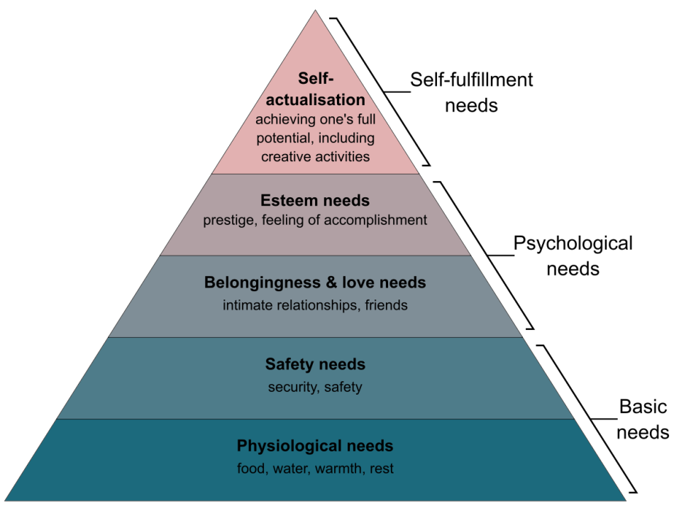

1. **Physiological needs:-**

* The physiological needs are regarded as the most basic of the needs that humans have.
* These are basic biological needs such as food, water, shelter, and sleep.
* Physiological needs are the most basic and fundamental of all human needs, and they are considered the foundation of Maslow's hierarchy of needs.
* These needs are related to the maintenance and survival of life, and they must be met in order for an individual to function at a basic level.
* These are needs that are very crucial for our survival.
* **The examples** of physiological needs are food, shelter, warmth, health, homeostasis and water, etc.

1. **Safety Needs:-**

* Once physiological needs are met, the next priority is safety and security, including protection from harm and stability in one's environment.
* Once the basic needs of food, shelter, water, etc are fulfilled, there is an innate desire to move to the next level.
* The next level is known as the safety needs.
* Here the primary concern of the individual is related to safety and security. At this level, the needs for security and safety become primary.
* People want control and order in their lives. Some of the basic security and safety needs include:
* [Financial security](https://www.verywellmind.com/understanding-and-preventing-financial-stress-3144546)
* Health and wellness
* Safety against accidents and injury
* The various actions taken by an individual in ensuring safety and security are finding a job, getting an insurance policy, choosing a secure neighbourhood for staying with family, etc.

1. **Social needs (Belongingness and love):-**

* This is the third level in the need hierarchy theory.
* It is that stage where an individual having fulfilled his physiological needs as well as safety needs seeks acceptance from others in the form of love, belongingness.
* In this stage, human behaviour is driven by emotions and the need for making emotional relationships is dominant here.
* The following examples can satisfy this need:

1. Friendship

2. Family

3. Social Groups

* When an individual is deprived of the above needs, he/she feels lonely and depressed.
* In order to avoid [loneliness](https://www.verywellmind.com/loneliness-causes-effects-and-treatments-2795749), [depression](https://www.verywellmind.com/depression-4157261), and anxiety, it is important for people to feel loved and accepted by others.
* Personal relationships with friends, family, and lovers play an important role.

1. **Esteem needs:-**

* This is considered as the fourth level of the hierarchy of needs theory.
* This category includes the need for self-esteem, respect from others, and recognition for one's achievements.
* It is related to the need of a person being recognised in the society.
* It deals with getting recognition, self respect in the society.
* The need for recognition and acceptance arises when a person has fulfilled their need for love and belongingness.
* In addition to recognition from others, there is a need for the person to develop self esteem and personal worth.

**[Together, the esteem and social levels make up what is known as the "psychological needs" of the hierarchy]**

1. **Self-Actualization Needs:-**

* This is the final level of the theory of hierarchy of needs as proposed by Maslow.
* The highest level of needs is self-actualization, or the drive to reach one’s full potential and finds meaning and purpose in life.
* It is the highest level of needs and is known as the self-actualization needs.
* It relates to the need of an individual to attain or realise the full potential of their ability or potential.
* At this stage, all individuals try to become the best version of themselves.
* In other words, self actualisation is the journey of personal growth and development.
* According to Maslow, once lower level needs are met, individuals will focus on meeting higher level needs, and they will continue to do so until they reach self-actualization. However, the theory is

not meant to be prescriptive and individuals may prioritize different needs at different times in their lives.

1. **DOUGLAS MCGREGOR:-**

* Douglas McGregor was born in the year 1960. He was a great a thinker, leader, management and[leadership](https://www.toppr.com/guides/business-studies/directing/leadership/) theorist.
* Douglas McGregor developed two contrasting theories that explained how managers' beliefs about what motivates their people can affect their management style.
* He labelled these as **Theory X and Theory Y**. These theories continue to be important even today.

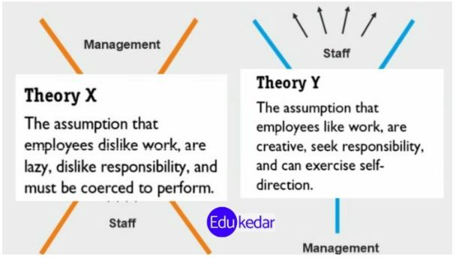

1. **Theory X** **(Dominant management approach)**:

* Theory X is based on negative assumptions regarding the typical worker.
* This management style assumes that the typical worker has little ambition, avoids responsibility, and is individual-goal oriented.
* In general, Theory X style managers believe their employees are less intelligent, lazier, and work solely for a sustainable income. Management believes employees' work is based on their own self-interest.
* Managers who believe employees operate in this manner are more likely to use rewards or **punishments as motivation**.
* Due to these assumptions, Theory X concludes the typical [workforce](https://en.wikipedia.org/wiki/Workforce) operates more [efficiently](https://en.wikipedia.org/wiki/Efficiency_(economics)) under a hands-on approach to management.
* This style of management assumes that workers:

1. Dislike their work.
2. Avoid responsibility and need constant direction.
3. Have to be controlled, forced and threatened to deliver work.
4. Need to be supervised at every step.
5. Have no incentive to work or ambition, and therefore need to be enticed by [rewards](https://www.mindtools.com/atahfvp/rewarding-your-team) to achieve goals.
6. **Theory Y (Employee centred approach):**

* Theory Y is based on positive assumptions regarding the typical worker.
* Theory Y managers assume employees are [internally motivated](https://en.wikipedia.org/wiki/Intrinsic_motivation), enjoy their job, and work to better themselves without a direct reward in return.
* These managers view their employees as one of the most valuable assets to the company, driving the internal workings of the corporation.
* Employees additionally tend to take full [responsibility](https://en.wikipedia.org/wiki/Duty) for their work and do not need close [supervision](https://en.wikipedia.org/wiki/Supervision) to create a quality product.
* This style of management assumes that workers are:

1. Happy to work on their own initiative.
2. More involved in decision making.
3. Self-motivated to complete their tasks.
4. Enjoy [taking ownership](https://www.mindtools.com/a3d1bc8/holding-people-accountable) of their work.
5. Seek and accept responsibility, and need little direction.
6. View work as fulfillling and challenging.
7. Solve problems creatively and imaginative

**Key difference between THEORY X & THEORY Y**

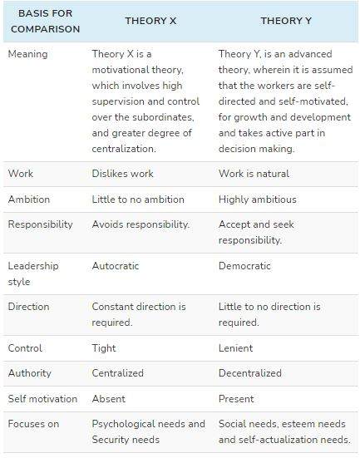

**MANAGEMENT THINKERS (Contemporary)**

1. **PETER F. DRUCKER:-**

* The father of modern **corporate management**.
* Peter Drucker is often considered to be the world’s most influential corporate guru.
* His ideas and thoughts revolutionized corporate management in the later half of the 20th century.
* Drucker questioned why in both the classical and human relations schools of management, effectiveness was automatically considered to be a natural and expected outcome.
* According to him effectiveness was more important than efficiency and was the foundation of every organization.
* He thereby developed Management by Objectives (MBO) through his 1954 book ‘The Practice of Management’.
* MBO deals with a certain type of interaction, specific to a manager and his employee.
* MBO is based on the thinking that various hierarchies within companies need to be integrated.

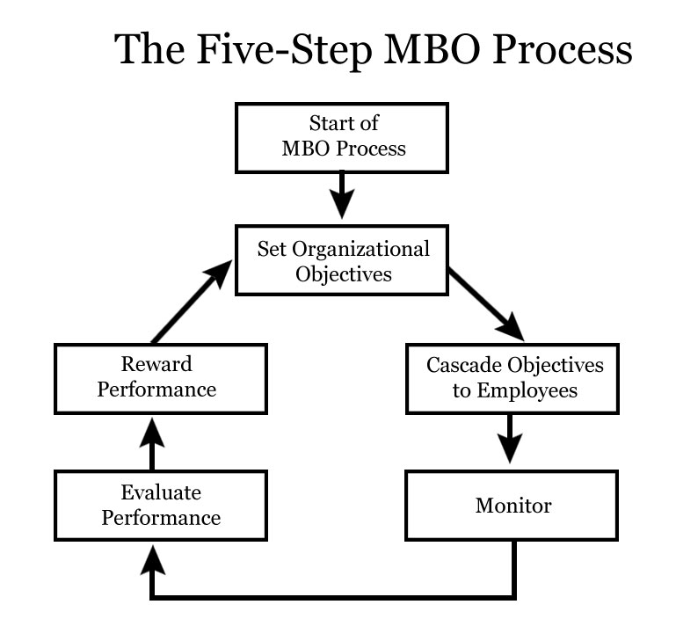

**Involving employees in goal-setting**

* The process of Management by Objectives (MBO) typically involves the following steps:-

1. **Set Organizational objectives:**

* The first step is to establish clear and specific objectives for the organization, departments, and individual employees.
* These objectives should be measurable, time-bound, and aligned with the overall mission and strategy of the organization.
* The company heads determine or revise the current goals of the organization.
* These goals are derived from the mission of the company. This is already defined in most cases except start-ups..

1. **Involving employees in goal-setting:**

* The second step is to involve employees in the goal-setting process, as they are the ones who will be working to achieve these objectives.
* Employees should be encouraged to provide input and feedback on the objectives set for them. The employees will have specific objectives depending on their position.
* It is recommended to design only one to three objectives per person. Anything beyond that would lead to confusion and a lack of focus.
* 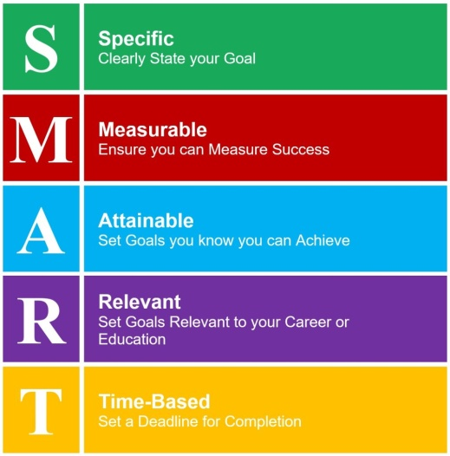Drucker mentions the following **SMART** goals for a company. The goals should be:-

1. **Specific,** it cannot be vague/unclear.
2. **Measurable**, so that the organization can assess if they are succeeding.
3. **Acceptable**, so that they won’t seem unfair to the employees.
4. **Realistic;** otherwise, goals would never be met.
5. **Time-bound**, to measure results and determine success.
6. **Monitoring progress:**

* The fourth step is to regularly monitor progress towards the objectives and make any necessary adjustments to the action plans.
* The process should be monitored at all times, as results will determine the future plans. It also prevents the management from losing track of progress. By doing so, organizations can avoid failures by spotting flaws in the process early on.
* This involves tracking and measuring the performance of individual employees and the organization as a whole.

1. **Evaluating performance:**

* The final step is to evaluate the performance of employees and the organization based on their achievement of the objectives.
* This involves conducting performance reviews and providing feedback to employees on their progress.
* It’s essential to use solid metrics to evaluate the performance. Firms should focus on the key performance metrics used from the beginning.
* Firms should define boundaries for what is acceptable, what is successful, and what could be an utter failure.
* Successes should be rewarded, and failures need to be addressed.

1. **Reward performance:**

* All employees must get a clear response on their performance. If they do well, they should be rewarded.
* This motivates them to keep up the good work.
* Employees who did not achieve the goals, however, need to figure out the flaws in their process.
* They need to come up with a strategy to overcome the flaws and improve.

1. **MICHAEL PORTER:-**

* Michael Porter is a renowned Harvard Business School professor and a leading authority on competitive strategy and the competitiveness of nations, states, and regions.
* He is best known for his **Five Forces Framework**, which is used by companies to analyze the competitive environment and develop a strategic plan.
* Porter has also made significant contributions to the fields of corporate strategy, the economics of industries, and the role of business in society.
* He is the author of several influential books, including **"Competitive Strategy**, **“Techniques for Analyzing Industries and Competitors"** and **"The Competitive Advantage of Nations."**
* Porter's Five Forces is a model that identifies and analyzes five competitive forces that shape every industry and helps determine an industry's weaknesses and strengths.
* Five Forces analysis is frequently used to identify an industry's structure to determine corporate strategy.
* The model identifies five forces that determine the competitive intensity and attractiveness of a market.
* **The Five Forces are :-**

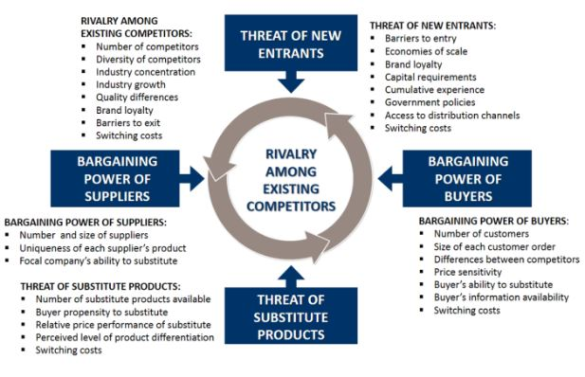

1. **Threat of new Entrance:-**

* The threat of new entrants refers to the ease with which new competitors can enter the market.
* Factors that can increase the threat of new entrants include low barriers to entry, access to distribution channels, and the availability of capital.
* New Entrants came up with new capacity and desire to gain market share; therefore, they are a threat to an existing corporation.
* To discourage them, existing organizations create barriers like using economies of scale for having absolute cost advantage; they ensure minimal customer switching from the existing brand so that acquiring customers becomes a costly affair for new entrants to enter the industry.

1. **Threat of substitutes:-**

* The threat of substitutes refers to the availability of alternative products or services that can be used instead of the products or services offered by a company.
* Substitutes can come from within the same industry or from outside the industry.
* In order to discover these alternatives one should look beyond similar products that are branded differently by competitors.
* Instead, every product that serves a similar need for customers should be taken into account.
* **For Example:** Energy drink like Redbull for instance is usually not considered a competitor of coffee brands such as Nespresso or Starbucks. However, since both coffee and energy drink fulfill a similar need (i.e. staying awake/getting energy), customers might be willing to switch from one to another if they feel that prices increase too much in either coffee or energy drinks.

1. **Bargaining power of suppliers:**

* The bargaining power of suppliers refers to the ability of suppliers to influence the prices and terms of their products or services.
* Factors that can increase the bargaining power of suppliers include the availability of alternative suppliers, the concentration of suppliers, and the importance of the products or services they supply to the buyer.
* Suppliers play an important role in the normal course of business.
* They can affect business by increasing factor prices and reducing the quality of the raw material.
* So, to cope up with these challenges marketers try to find out- Supplier switching costs relative to firm switching costs, Degree of differentiation of inputs, Impact of inputs on cost and differentiation, Presence of substitute inputs, Strength of distribution channel, Supplier concentration to the firm concentration ratio and try to build a good relationship with their suppliers to ensure uninterrupted supply in the future.

1. **Bargaining power of buyers:**

* The bargaining power of buyers refers to the ability of buyers to influence the prices and terms of the products or services they purchase.
* Factors that can increase the bargaining power of buyers include the availability of alternative products or services, the concentration of buyers, and the importance of the products or services they purchase to the seller.
* This force analyzes to what extent the customers are able to put the company under pressure, which also affects the customer’s sensitivity to price changes.
* The customers have a lot of power when there aren’t many of them and when the customers have many alternatives to buy from.
* **For example:**
* The internet has allowed customers to become more informed and therefore more empowered. Customers can easily compare prices online, get information about a wide variety of products and get access to offers from other companies instantly.

1. **Rivalry among existing competitors:**

* The rivalry among existing competitors refers to the intensity of competition among existing players in the market.
* Factors that can increase rivalry include the number and size of competitors, the growth rate of the industry, and the level of differentiation among products or services.
* The decision of one will affect other’s profit share.
* **For Example:** Aeroplane industry, during the high demand Vistara increase prices, Air India will also increase the prices for their flights to earn high profits.
* Firms can face this situation by having a Sustainable competitive advantage through innovation, Competition between online and offline companies, Level of advertising expense, Powerful competitive strategy, Firm concentration ratio, Degree of transparency.

1. **C.K PRAHLAD (Coimbatore Krishnarao Prahalad ):-**

* 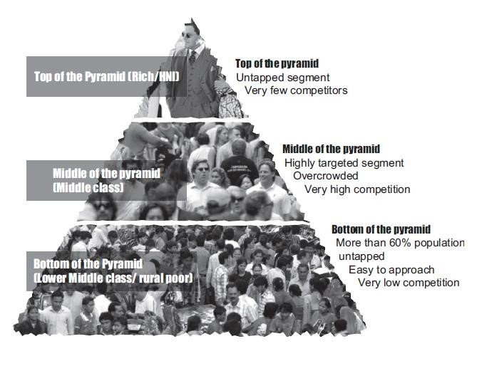He co-authored "[***Core Competence of the Corporation***](https://en.wikipedia.org/wiki/Core_competency)***"[***with [***Gary Hamel***](https://en.wikipedia.org/wiki/Gary_Hamel) and ***"***[***The Fortune at the Bottom of the Pyramid***](https://en.wikipedia.org/wiki/The_Fortune_at_the_Bottom_of_the_Pyramid)***"***with [**Stuart L. Hart**](https://en.wikipedia.org/wiki/Stuart_L._Hart), about business opportunity in serving the [**Bottom of the Pyramid**](https://en.wikipedia.org/wiki/Bottom_of_the_Pyramid)**.**

1. **“**[***The Fortune at the Bottom of the Pyramid* *by C.K. Prahalad***](https://www.amazon.com/Fortune-Bottom-Pyramid-Eradicating-Poverty/dp/8177587765)**”** reframed the world’s poorest citizens as resilient and creative entrepreneurs and value-conscious consumers.
2. He believed these consumers could be tapped to help create opportunities for economic growth.
3. He introduced a **core competency**  concept in management theory
4. It can be defined as **"a harmonized combination of multiple resources and skills that distinguish a firm in the marketplace"** and therefore are the foundation of companies' competitiveness.
5. Core competencies fulfil three criteria’s:-
6. Provides potential access to a wide variety of markets.
7. Should make a significant contribution to the perceived customer benefits of the end product.
8. Difficult to imitate by competitors.
9. For example, a company's core competencies may include precision mechanics, fine optics, and micro-electronics. These help it build cameras, but may also be useful in making other products that require these competencies.
10. In throwing out existing data and process led theories of strategy formation, Prahalad and Hamel developed a simple model of how corporations can achieve competitive advantage.
11. This simplification of their ideas is mine and any errors of interpretation I have introduced are mine too.
12. **Step 1: Corporate Imagination :-**

* This is where corporate leaders visualise new markets and how to exploit them ahead of their competitors. They argued that to do this effectively, executives have to:

1. get away from their natural focus on existing markets
2. look for new product concepts
3. be prepared to challenge radically their old assumptions about pricing (this idea would recur in Prahalad’s thinking about how to create markets at the Bottom of the Pyramid)
4. lead customers by creating expectations, rather than follow them by meeting expectations

* Hamel and Prahalad had little time for small scale intrapreneurial innovation. They advocated big, revolutionary changes in markets that would allow a corporation to dominate, such as:

1. adding wholly new functionality to your existing products
2. delivering your proven functionality through new products
3. using existing products to deliver functionality in new ways

* To do this, they argue that an organisation must understand its *‘core competencies’*– the abilities it has to create and innovate by bringing together its skills, technologies, assets, and relationships in ways that dominate multiple markets by offering big benefits to customers in a way that competitors find hard to duplicate.
* The threat of relying on core competencies, however, is two-fold. Firstly, it may cause market and product diversification into arenas where the corporation has insufficient depth of understanding or presence to be effective.
* This can lead to large failures. Alternatively, over-focus on core competency leads to a rigidity of thinking that is reinforced by a sense of comfortableness, and leads to a sense of complacency.
* Such circumstances lead to being replaced in your core markets by insurgent competitors.

1. **Step 2: Implementation**

* Hamel and Prahalad’s focus on core competencies leads them to focus what they say about implementation on building up core competencies and their supporting infrastructures of assets, resources and technologies.

1. **Step 3: Consolidate your Control of Emerging Markets**

* You do this through what they call*‘Expeditionary Marketing’* to understand how the parameters of feature-sets, performance, and pricing need to be balanced to penetrate, consolidate and dominate your market.

**The Bottom of the Pyramid:-**

* How do you build a market among people who are too poor to buy your products?
* By re-thinking entirely how you deliver your products and the pricing model you use.
* Prahalad was able to find and research numerous case studies that show how corporations can do this successfully, to create:- ***Affordability*** – creating offerings that dramatically change what people need to pay and how they can pay for it

***Accessibility*** – thinking carefully about the local context, rather than applying first-world distribution models

***Availability*** – getting products to where they are needed, when they are needed, in a form that makes it possible for people to buy.

**INDIAN THINKERS IN MANAGEMENT:-**

1. 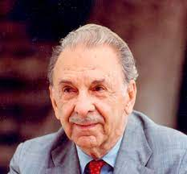**JRD TATA (Jehangir Ratanji Dadabhoy Tata)**

* He was a prominent Indian industrialist and a distinguished management thinker. Born in 1904, JRD Tata played a crucial role in shaping the Tata Group, one of India's largest and oldest conglomerates.
* As a management thinker, he emphasized the importance of ethical and socially responsible business practices.
* JRD Tata's management philosophy was characterized by a commitment to employee welfare, community development, and environmental sustainability.
* Under his leadership, the Tata Group diversified into various industries, including steel, automobiles, and aviation, and became known for its emphasis on innovation and quality.
* His approach to management reflected a holistic perspective, considering not only the financial aspects of business but also the broader impact on society.
* JRD Tata's legacy includes not only his contributions to the industrial development of India but also his visionary leadership, making him a revered figure in Indian management history.
* He was an Indian aviator, industrialist, entrepreneur and chairman of TataGroup.​
* He started with 14 enterprises and after half a century, when he left, Tata & Sons was a corporation of 95 enterprises.​
* He launched India's first international airline.​
* He Established Asia first cancer hospital, the **Tata Memorial Center for Cancer, Research and Treatment, Bombay, 1941.**​
* Initiated the principles of an eight-hour working day, free medical aid, workers provident scheme, workmen accident compensation schemes​

JRD Tata's contributions in the field of management can be summarized as follows:

1. **Ethical Leadership:**

JRD Tata was a trailblazer in advocating ethical business practices, emphasizing integrity and honesty in all dealings.

1. **Social Responsibility:**

He championed the concept of corporate social responsibility, stressing the importance of businesses contributing positively to the welfare of society.

1. **Employee Welfare:**

JRD Tata prioritized the well-being of employees, introducing progressive measures for their welfare, including employee benefits, healthcare, and educational initiatives.

1. **Community Development:**

Recognizing the role of corporations in community development, Tata initiated several projects that aimed at uplifting the communities surrounding the Tata Group's operations.

1. **Diversification:**

Under his leadership, the Tata Group diversified into various industries, fostering innovation and ensuring the conglomerate's resilience across different sectors.

1. **Innovation and Quality:**

JRD Tata instilled a culture of innovation and quality across the Tata Group, contributing to the organization's reputation for producing high-quality products and services

1. **Holistic Management:**

He adopted a holistic approach to management, considering not only financial aspects but also the broader impact of business on society and the environment.

1. **Visionary Leadership:**

JRD Tata's visionary leadership played a pivotal role in the growth and success of the Tata Group, making it a global business conglomerate.

1. **Indian Management Pioneer:**

He is regarded as a pioneer in Indian management, setting standards for leadership and corporate governance that continue to influence business practices in the country.

1. **Legacy in Business:**

JRD Tata's legacy extends beyond business success to encompass values and principles that have shaped the Tata Group's enduring impact on India's industrial landscape.

1. **Sustainable Practices:**

He emphasized sustainable business practices, recognizing the importance of environmental conservation and responsible resource management.

1. **Contribution to National Development:**

Through his leadership and the Tata Group's initiatives, JRD Tata made significant contributions to the economic and industrial development of India, leaving a lasting impact on the nation's progress.

Top of Form

1. 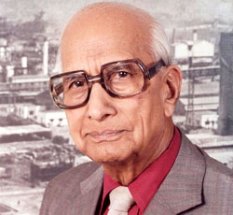**GD Birla:**

* G.D. Birla, or Ghanshyam Das Birla, was a renowned Indian industrialist and a key architect of the Birla Group, a major conglomerate in India.
* As one of the leading Indian thinkers in management, his contributions encompassed various dimensions:

1. **Industrial Leadership:**

G.D. Birla provided visionary leadership in steering the growth and diversification of the Birla Group across multiple industries.

1. **Business Diversification:**

Under his guidance, the Birla Group expanded into diverse sectors such as textiles, cement, chemicals, and more, showcasing strategic business diversification.

1. **Entrepreneurial Spirit:**

Birla exhibited a strong entrepreneurial spirit, identifying and seizing opportunities to establish and manage successful enterprises.

1. **Ethical Business Practices:**

He emphasized ethical standards and integrity in business operations, establishing a foundation of trust and credibility for the Birla Group.

1. **Philanthropy:**

G.D. Birla actively engaged in philanthropy, contributing to societal welfare through initiatives in education, healthcare, and community development.

1. **Community Development:**

Recognizing the importance of community well-being, he initiated projects aimed at the holistic development of communities associated with the Birla Group.

1. **Corporate Governance:**

Birla advocated for sound corporate governance practices, promoting transparency and accountability within the organization.

1. **Social Responsibility:**

He understood the significance of corporate social responsibility, integrating social and environmental considerations into the Birla Group's business ethos.

1. **Nation Building:**

G.D. Birla played a vital role in India's industrialization and economic development, contributing to the nation's progress during the pre-independence and post-independence eras.

1. **Educational Contributions:**

He made substantial investments in education, establishing educational institutions that have become significant contributors to the development of human capital.

1. **Textile and Industrial Growth:**

His contributions to the textile industry and industrial expansion contributed to the overall growth of the manufacturing sector in India.

1. **Legacy:**

G.D. Birla's legacy extends beyond business success, influencing the principles and values of the Birla Group and leaving a lasting impact on the landscape of Indian business and management.

1. **Ramkrishna Bajaj:**

* Ramkrishna Bajaj was a notable Indian industrialist and a key figure in the Bajaj Group.
* His contributions to business and management can be summarized in the following aspects:

1. **Industrialist:**

Ramkrishna Bajaj was a distinguished industrialist who played a crucial role in the development and expansion of the Bajaj Group, a prominent conglomerate in India.

1. **Business Growth:**

Under his leadership, the Bajaj Group witnessed substantial growth and diversification, establishing its presence in various sectors including automobiles, finance, and consumer goods.

1. **Entrepreneurial Leadership:**

Bajaj demonstrated strong entrepreneurial leadership, guiding the Bajaj Group through challenges and adapting to changing business landscapes.

1. **Ethical Business Practices:**

He emphasized ethical business practices, fostering a culture of integrity and transparency within the organization.

1. **Philanthropy:**

Ramkrishna Bajaj was actively involved in philanthropic activities, contributing to social causes and community development.

1. **Community Welfare:**

Recognizing the importance of community welfare, he initiated projects aimed at enhancing the well-being of the communities associated with the Bajaj Group.

1. **Corporate Governance:**

Bajaj advocated for sound corporate governance practices, ensuring responsible and accountable management within the Bajaj Group.

1. **Social Responsibility:**

He prioritized corporate social responsibility, integrating social and environmental considerations into the business strategies of the Bajaj Group.

1. **Nation Building:**

Through his contributions to industry and commerce, Ramkrishna Bajaj played a role in India's economic development, contributing to the nation-building process.

1. **Educational Initiatives:**

Bajaj supported educational initiatives, recognizing the importance of education in societal development and human capital enhancement.

1. **Automobile Industry Growth:**

His leadership in the Bajaj Group significantly contributed to the growth and success of the Indian automobile industry.

1. **Legacy:**

Ramkrishna Bajaj's legacy extends beyond business achievements, leaving a lasting impact on the principles and values of the Bajaj Group and contributing to the broader landscape of Indian business and management.

**Top of Form**

**MCQ’s**

**1. Who is known as the father of scientific management?**

a. F.W. Taylor

b. Henry Fayol

c. George Elton Mayo

d. A. H. Maslow

**Answer: a**

**2. F.W. Taylor's scientific management focuses on:**

a. Human Relations

b. Efficiency and Productivity

c. Hierarchy of Needs

d. Theory X and Theory Y

**Answer: b**

3. Which of the following principles is associated with Henry Fayol?

a. Unity of Direction

b. Scientific Management

c. Hawthorne Effect

d. Hierarchy of Needs

**Answer: a**

**4. The Hawthorne Studies, highlighting the importance of social factors at work, were conducted by:**

a. F.W. Taylor

b. Henry Fayol

c. George Elton Mayo

d. A. H. Maslow

**Answer: c**

**5. According to Fayol, the principle of 'Esprit de Corps' emphasizes:**

a. Unity of Direction

b. Team Spirit

c. Hierarchy of Needs

d. Scientific Management

**Answer: b**

**6. A. H. Maslow is best known for his theory of:**

a. Bureaucracy

b. Hierarchy of Needs

c. Scientific Management

d. Theory X and Theory Y

**Answer: b**

**7. Douglas McGregor's Theory X assumes that:**

a. Employees are self-motivated

b. Employees dislike responsibility

c. Employees seek higher-order needs

d. Employees are naturally industrious

**Answer: b**

**8. Which of the following is not a component of Maslow's Hierarchy of Needs?**

a. Physiological Needs

b. Esteem Needs

c. Safety Needs

d. Marketing Needs

**Answer: d**

**9. The principle of 'Unity of Command' is associated with:**

a. F.W. Taylor

b. Henry Fayol

c. George Elton Mayo

d. Douglas McGregor

**Answer: b**

**10. According to Taylor, what is the primary motivator for employees?**

a. Social Interaction

b. Job Security

c. Money

d. Recognition

**Answer: c**

**11. What is the focus of Frederick Winslow Taylor's scientific management?**

a. Human Relations

b. Efficiency and Productivity

c. Hierarchy of Needs

d. Theory X and Theory Y

**Answer: b**

**12. Henry Fayol's management principles are often categorized into how many groups?**

a. 7

b. 10

c. 14

d. 21

**Answer: c**

**13. The concept of 'Scalar Chain' is associated with:**

a. F.W. Taylor

b. Henry Fayol

c. George Elton Mayo

d. Douglas McGregor

**Answer: b**

**14. Elton Mayo's experiments at the Hawthorne Works primarily focused on:**

a. Physical working conditions

b. Employee motivation

c. Social and psychological factors

d. Time and motion studies

**Answer: c**

**15. A. H. Maslow's Hierarchy of Needs starts with:**

a. Safety Needs

b. Self-Actualization

c. Physiological Needs

d. Esteem Needs

**Answer: c**

**16. According to Douglas McGregor, Theory Y assumes that:**

a. Employees dislike work

b. Employees need close supervision

c. Employees can be self-motivated

d. Employees prefer Theory X

**Answer: c**

**17. Which management thinker emphasized the principle of 'Equity'?**

a. F.W. Taylor

b. Henry Fayol

c. Elton Mayo

d. A. H. Maslow

**Answer: c**

**18. According to Henry Fayol, 'Remuneration of Personnel' should be fair and:**

a. Based on market rates

b. Tied to individual performance

c. Linked to profit-sharing

d. Sufficient to guarantee a decent standard of living

**Answer: d**

**19. Elton Mayo's experiments led to the discovery of the:**

a. Hawthorne Effect

b. Pygmalion Effect

c. Bystander Effect

d. Placebo Effect

**Answer: a**

**20. Maslow's 'Esteem Needs' include:**

a. Friendship and love

b. Self-respect and confidence

c. Breathing and sleep

d. Security of employment

**Answer: b**

**21. According to Taylor, what is the role of management in scientific management?**

a. Participative decision-making

b. Maximum employee autonomy

c. Providing detailed work instructions

d. Employee motivation programs

**Answer: c**

**22. Henry Fayol's principle of 'Centralization' suggests:**

a. Decentralized decision-making

b. Centralized authority at the top

c. Team-based decision-making

d. Matrix organizational structure

**Answer: b**

**23. The concept of 'Zone of Indifference' is associated with:**

a. Douglas McGregor

b. George Elton Mayo

c. A. H. Maslow

d. Henry Fayol

**Answer: d**

**24. Maslow's 'Safety Needs' include:**

a. Physical well-being

b. Social belongingness

c. Self-actualization

d. Esteem and recognition

**Answer: a**

**25. Which of the following is not one of Fayol's principles of management?**

a. Unity of Command

b. Unity of Direction

c. Unity of Communication

d. Unity of Purpose

**Answer: c**

**26. According to Douglas McGregor, Theory X is based on the assumption that employees:**

a. Prefer self-direction

b. Dislike responsibility

c. Seek higher-order needs

d. Are naturally cooperative

**Answer: b**

**27. Elton Mayo's experiments were conducted at the Western Electric plant in:**

a. Chicago

b. New York

c. Detroit

d. Los Angeles

**Answer: a**

**28. The 'Chain of Command' principle is associated with:**

a. Henry Fayol

b. F.W. Taylor

c. George Elton Mayo

d. A. H. Maslow

**Answer: a**

**29. According to Maslow, which needs involve a desire for self-respect, confidence, and achievement?**

a. Social Needs

b. Safety Needs

c. Esteem Needs

d. Physiological Needs

**Answer: c**

**30. Douglas McGregor's Theory Y assumes that employees:**

a. Dislike work

b. Need close supervision

c. Are motivated by higher-order needs

d. Prefer routine tasks

**Answer: c**

**31. According to Taylor, what is the role of workers in scientific management?**

a. Active participation in decision-making

b. Following instructions of management

c. Collaborative decision-making with management

d. Autonomous decision-making

**Answer: b**

**32. Henry Fayol's principle of 'Order' emphasizes:**

a. A specific place for everything

b. Authority and responsibility

c. Unity of Direction

d. Teamwork and collaboration

**Answer: a**

**33. What did Elton Mayo conclude from the Hawthorne Studies?**

a. Money is the primary motivator

b. Social and psychological factors impact productivity

c. Scientific management is the most effective approach

d. Employees prefer routine tasks

**Answer: b**

**34. According to Maslow, which needs involve friendship, intimacy, and a sense of belonging?**

**a. Safety Needs**

**b. Physiological Needs**

**c. Social Needs**

**d. Esteem Needs**

**Answer: c**

**35. Douglas McGregor's Theory X assumes that employees need:**

a. Autonomy and empowerment

b. Close supervision and control

c. Social interaction

d. Flexibility and creativity

**Answer: b**

**36. The principle of 'Subordination of Individual Interest to General Interest' is associated with:**

a. Henry Fayol

b. F.W. Taylor

c. Elton Mayo

d. A. H. Maslow

**Answer: a**

**37. Maslow's 'Self-Actualization Needs' involve:**

a. Basic survival needs

b. Personal growth and realization of potential

c. Social belongingness

d. Esteem and recognition

**Answer: b**

**38. According to Douglas McGregor, Theory Y is based on the assumption that employees:**

a. Dislike work

b. Are motivated by higher-order needs

c. Prefer routine tasks

d. Need close supervision

**Answer: b**

**39. The concept of 'Psychological Contract' is associated with:**

a. George Elton Mayo

b. A. H. Maslow

c. Douglas McGregor

d. F.W. Taylor

**Answer: a**

**40. Maslow's 'Physiological Needs' include:**

a. Friendship and love

b. Breathing and sleep

c. Self-respect and confidence

d. Security of employment

**Answer: b**

**41. According to Taylor, what is the purpose of time and motion studies in scientific management?**

a. Determine the social needs of employees

b. Improve efficiency and productivity

c. Establish a hierarchy of needs

d. Understand employee motivation

**Answer: b**

**42. Fayol's principle of 'Initiative' encourages:**

a. Centralized decision-making

b. Employee creativity and innovation

c. Routine and repetitive tasks

d. Strict adherence to rules

**Answer: b**

**43. The 'Gantt Chart' is associated with:**

a. Henry Fayol

b. F.W. Taylor

c. George Elton Mayo

d. A. H. Maslow

**Answer: b**

**44. Maslow's 'Esteem Needs' involve:**

a. Social belongingness

b. Physical well-being

c. Self-respect and confidence

d. Safety and security

**Answer: c**

**45. Douglas McGregor's Theory X assumes that employees are inherently:**

a. Lazy and unambitious

b. Cooperative and motivated

c. Creative and innovative

d. Adaptive and flexible

**Answer: a**

**46. According to Fayol, the principle of 'Unity of Direction' suggests:**

a. Centralized decision-making

b. Team-based decision-making

c. Autonomous decision-making

d. Decentralized decision-making

**Answer: a**

**47. Elton Mayo's experiments were conducted in collaboration with the:**

a. Western Electric Company

b. Ford Motor Company

c. General Electric Company

d. IBM Corporation

**Answer: a**

**48. The concept of 'Theory Z' is associated with:**

a. F.W. Taylor

b. Douglas McGregor

c. A. H. Maslow

d. Henry Fayol

**Answer: b**

**49. According to Maslow, 'Safety Needs' involve:**

a. Friendship and love

b. Breathing and sleep

c. Physical well-being

d. Self-respect and confidence

**Answer: c**

**50. Douglas McGregor's Theory X assumes that employees are motivated primarily by:**

a. Higher-order needs

b. Money and rewards

c. Social interaction

d. Job satisfaction

**Answer: b**

**51. Who developed the concept of the 'Scalar Chain' in management?**

a. F.W. Taylor

b. Henry Fayol

c. Elton Mayo

d. A. H. Maslow

**Answer: b**

**52. Douglas McGregor's Theory Y assumes that employees have a natural inclination towards:**

a. Autonomy and self-control

b. Strict supervision and control

c. Routine and repetitive tasks

d. Minimal responsibility

**Answer: a**

**53. According to Maslow, which need involves the desire for creativity, problem-solving, and acceptance of facts?**

a. Esteem Needs

b. Self-Actualization Needs

c. Social Needs

d. Safety Needs

**Answer: b**

**54. The term "Bureaucracy" is closely associated with the works of:**

a. F.W. Taylor

b. Henry Fayol

c. Max Weber

d. Elton Mayo

**Answer: c**

**55. What is the primary focus of Henry Fayol's principle of 'Unity of Command'?**

a. Team collaboration

b. Employee autonomy

c. Clear reporting relationships

d. Employee motivation programs

**Answer: c**

**56. In Maslow's Hierarchy of Needs, which level represents the need for friendship, intimacy, and a sense of belonging?**

a. Physiological Needs

b. Safety Needs

c. Social Needs

d. Esteem Needs

**Answer: c**

**57. What is the core idea behind Douglas McGregor's Theory Z?**

a. Employees are motivated by higher-order needs

b. Employees are inherently lazy and unambitious

c. Employees seek routine and repetitive tasks

d. Employees thrive in a cooperative and supportive work environment

**Answer: d**

**58. The principle of 'Division of Work' is a fundamental concept in the works of:**

a. F.W. Taylor

b. Henry Fayol

c. Adam Smith

d. Elton Mayo

**Answer: c**

**59. According to Taylor, what is the primary goal of scientific management?**

a. Employee satisfaction

b. Maximum efficiency and productivity

c. Social interaction

d. Employee empowerment

**Answer: b**

**60. Which management thinker introduced the concept of 'Zone of Indifference'?**

a. Henry Fayol

b. F.W. Taylor

c. A. H. Maslow

d. Douglas McGregor

**Answer: a**

**61. The Gantt Chart is a visual tool associated with:**

a. Henry Fayol

b. F.W. Taylor

c. Elton Mayo

d. Douglas McGregor

**Answer: b**

**62. According to Maslow, which need involves the desire for a safe and secure physical and emotional environment?**

a. Safety Needs

b. Esteem Needs

c. Self-Actualization Needs

d. Social Needs

**Answer: a**

**63. The 'Hawthorne Effect' refers to:**

a. The impact of lighting on productivity

b. The impact of social and psychological factors on productivity

c. The impact of wages on employee motivation

d. The impact of hierarchy on decision-making

**Answer: b**

**64. Fayol's principle of 'Scalar Chain' emphasizes:**

a. Clear reporting relationships

b. Employee empowerment

c. Team collaboration

d. Employee motivation programs

**Answer: a**

**65. According to Taylor, what is the role of management in scientific management?**

a. Active participation in decision-making

b. Providing detailed work instructions

c. Collaborative decision-making with employees

d. Autonomy and self-control

**Answer: b**

**66. Elton Mayo's experiments led to the development of the concept of:**

a. Theory X and Theory Y

b. Hierarchy of Needs

c. The Hawthorne Effect

d. Bureaucracy

**Answer: c**

**67. What did Maslow propose as the highest level in his Hierarchy of Needs?**

a. Esteem Needs

b. Social Needs

c. Self-Actualization Needs

d. Safety Needs

**Answer: c**

**68. Which management thinker advocated for a participative management style and suggested that managers should act as coaches?**

a. Henry Fayol

b. F.W. Taylor

c. Elton Mayo

d. Douglas McGregor

**Answer: d**

**69. The concept of 'Theory Z' is an extension of the works of:**

a. F.W. Taylor

b. Douglas McGregor

c. A. H. Maslow

d. Henry Fayol

**Answer: b**

**70. According to Taylor, what is the significance of time and motion studies in scientific management?**

a. Enhance employee creativity

b. Improve efficiency and productivity

c. Foster team collaboration

d. Establish a hierarchy of needs

**Answer: b**

**81. Who is often regarded as the "father of modern management" and emphasized the importance of management by objectives?**

a. Peter F. Drucker

b. Michael Porter

c. C. K. Prahlad

d. J.R.D. Tata

**Answer: a**

**82. Michael Porter is best known for his work in:**

a. Total Quality Management

b. Strategic Management

c. Human Resource Management

d. Scientific Management

**Answer: b**

**83. C. K. Prahlad is famous for introducing the concept of:**

a. Core Competence

b. Six Sigma

c. SWOT Analysis

d. Kaizen

**Answer: a**

**84. Which Indian industrialist is known for his contributions to the fields of education and philanthropy, in addition to business?**

a. J.R.D. Tata

b. G.D. Birla

c. Ramkrishna Bajaj

d. Peter F. Drucker

**Answer: b**

**85. According to Peter F. Drucker, what is the primary purpose of a business?**

a. Maximizing shareholder wealth

b. Social responsibility

c. Customer satisfaction

d. Profit maximization

**Answer: c**

**86. Michael Porter's Five Forces model includes all of the following except:**

a. Bargaining power of suppliers

b. Threat of new entrants

c. Bargaining power of employees

d. Threat of substitute products

**Answer: c**

**87. C. K. Prahlad's book "The Fortune at the Bottom of the Pyramid" discusses:**

a. Corporate Governance

b. Corporate Social Responsibility

c. Market opportunities in low-income segments

d. Innovation and Creativity

**Answer: c**

**88. J.R.D. Tata is known for establishing:**

a. Tata Motors

b. Tata Consultancy Services (TCS)

c. Tata Steel

d. Tata Power

**Answer: c**

**89. What is the concept introduced by Peter F. Drucker that emphasizes the importance of focusing on a few key objectives rather than a multitude of tasks?**

a. Total Quality Management

b. Management by Objectives (MBO)

c. Core Competence

d. Business Process Reengineering

**Answer: b**

**90. Michael Porter's concept of "Cost Leadership" is associated with:**

a. Differentiation strategy

b. Focus strategy

c. Cost-minimization to gain a competitive advantage

d. Niche marketing

**Answer: c**

**91. C. K. Prahlad's concept of "Core Competence" suggests that organizations should focus on:**

a. Outsourcing non-core activities

b. Expanding product lines

c. Maximizing shareholder wealth

d. Diversification

**Answer: a**

**92. Which Indian industrialist played a key role in the establishment of the Indian Institute of Management, Ahmedabad (IIMA)?**

a. J.R.D. Tata

b. G.D. Birla

c. Ramkrishna Bajaj

d. C. K. Prahlad

**Answer: a**

**93. Peter F. Drucker's concept of "Management by Objectives" emphasizes:**

a. Centralized decision-making

b. Employee empowerment

c. Setting specific and measurable goals

d. Continuous improvement

**Answer: c**

**94. Michael Porter's generic strategies include:**

a. Cost Leadership, Differentiation, and Focus

b. Innovation, Quality, and Flexibility

c. Market penetration, Market development, and Product development

d. Efficiency, Effectiveness, and Empowerment

**Answer: a**

**95. C. K. Prahlad's concept of "The Core Competence of the Corporation" suggests that organizations should focus on:**

a. Outsourcing all activities

b. Maximizing shareholder wealth

c. Leveraging unique strengths and capabilities

d. Diversifying into unrelated industries

**Answer: c**

**96. Which Indian industrialist is associated with the formation of the Federation of Indian Chambers of Commerce and Industry (FICCI)?**

**a. J.R.D. Tata**

**b. G.D. Birla**

**c. Ramkrishna Bajaj**

**d. C. K. Prahlad**

**Answer: b**

**97. According to Peter F. Drucker, what is a crucial aspect of effective leadership?**

a. Micro-management

b. Innovation

c. Centralized decision-making

d. Autocratic leadership

**Answer: b**

**98. Michael Porter's model of "Value Chain" includes primary activities and:**

a. Support activities

b. Marketing activities

c. Outsourcing activities

d. Customer service activities

**Answer: a**

**99. C. K. Prahlad's book "The Bottom of the Pyramid" discusses business opportunities in:**

a. High-income segments

b. Low-income segments

c. Middle-income segments

d. Urban areas

**Answer: b**

**100. J.R.D. Tata received the Bharat Ratna, India's highest civilian award, for his contributions to:**

a. Sports

b. Science and Technology

c. Social Work

d. Business and Industry

**Answer: d**

**21. Which of the following is not one of the areas of competitive advantage according to Michael Porter's "Five Forces" model?**

a. Threat of new entrants

b. Bargaining power of suppliers

c. Bargaining power of customers

d. Government regulations

**Answer: d**

**22. C. K. Prahlad's concept of "Strategic Intent" emphasizes:**

a. Short-term goals

b. Long-term vision and ambitious goals

c. Cost-cutting measures

d. Customer satisfaction

**Answer: b**

**23. J.R.D. Tata served as the chairman of which Tata Group company for the longest period?**

a. Tata Steel

b. Tata Motors

c. Tata Consultancy Services (TCS)

d. Tata Power

**Answer: c**

**24. According to Peter F. Drucker, what is the role of marketing in a business?**

a. Selling products at any cost

b. Maximizing shareholder wealth

c. Creating and satisfying customers

d. Minimizing costs

**Answer: c**

**25. Michael Porter's "Diamond Model" includes all of the following factors except:**

a. Firm strategy, structure, and rivalry

b. Factor conditions

c. Demand conditions

d. Government regulations

**Answer: d**

**26. C. K. Prahlad's concept of "The Fortune at the Bottom of the Pyramid" suggests that:**

a. Companies should focus only on high-income segments

b. There are business opportunities in low-income segments

c. Profitability is only possible in the middle-income segments

d. Innovation is not necessary for success

**Answer: b**

**27. Who among the Indian thinkers played a significant role in the establishment of the Reserve Bank of India (RBI)?**

a. J.R.D. Tata

b. G.D. Birla

c. Ramkrishna Bajaj

d. C. K. Prahlad

**Answer: b**

**28. Peter F. Drucker is also known for his contributions to:**

a. Political Science

b. Sociology

c. Economics

d. Nonprofit Management

**Answer: d**

**29. Michael Porter's "Five Forces" model is commonly used for:**

a. Financial analysis

b. Human resource management

c. Industry analysis and strategy development

d. Quality management

**Answer: c**

**30. According to C. K. Prahlad, what is the key to corporate success?**

a. Cost-cutting measures

b. Innovation and Core Competence

c. Maximizing shareholder wealth

d. Market diversification

**Answer: b**

**101. Who is often regarded as the "father of modern management" and emphasized the importance of management by objectives?**

a. Peter F. Drucker

b. Michael Porter

c. C. K. Prahlad

d. J.R.D. Tata

**Answer: a**

**102. Michael Porter is best known for his work in:**

a. Total Quality Management

b. Strategic Management

c. Human Resource Management

d. Scientific Management

**Answer: b**

**103. C. K. Prahlad is famous for introducing the concept of:**

a. Core Competence

b. Six Sigma

c. SWOT Analysis

d. Kaizen

**Answer: a**

**104. According to Peter F. Drucker, what is the primary purpose of a business?**

a. Maximizing shareholder wealth

b. Social responsibility

c. Customer satisfaction

d. Profit maximization

**Answer: c**

**105. According to Michael Porter, what is the primary factor determining the intensity of competition in an industry?**

a. Bargaining power of suppliers

b. Threat of new entrants

c. Bargaining power of customers

d. The threat of substitute products or services

**Answer: d**

**106. C. K. Prahlad's concept of "Core Competence" suggests that organizations should focus on:**

a. Outsourcing non-core activities

b. Expanding product lines

c. Maximizing shareholder wealth

d. Diversification

**Answer: a**

**107. Which of the following is not one of Michael Porter's generic competitive strategies?**

a. Cost Leadership

b. Differentiation

c. Market Penetration

d. Focus

**Answer: c**

**108. According to Peter F. Drucker, what is the role of marketing in a business?**

a. Selling products at any cost

b. Maximizing shareholder wealth

c. Creating and satisfying customers

d. Minimizing costs

**Answer: c**

**109. In Michael Porter's Five Forces model, the bargaining power of buyers increases when:**

a. There are few substitute products available

b. Buyers are fragmented and purchase small quantities

c. There are high switching costs for buyers

d. Buyers have limited information about the industry

**Answer: b**

**110. C. K. Prahlad's concept of "Strategic Intent" emphasizes:**

a. Short-term goals

b. Long-term vision and ambitious goals

c. Cost-cutting measures

d. Customer satisfaction

**Answer: b**

**111. Peter F. Drucker's concept of "Management by Objectives" emphasizes:**

a. Centralized decision-making

b. Employee empowerment

c. Setting specific and measurable goals

d. Continuous improvement

**Answer: c**

**112. According to Michael Porter, the threat of substitute products is high when:**

a. There are few alternative products available

b. Substitutes are inferior in quality

c. Switching costs are low for customers

d. The industry is characterized by high brand loyalty

**Answer: c**

**113. C. K. Prahlad's book "The Fortune at the Bottom of the Pyramid" discusses:**

a. Corporate Governance

b. Corporate Social Responsibility

c. Market opportunities in low-income segments

d. Innovation and Creativity

**Answer: c**

**114. Peter F. Drucker's concept of "Innovation and Entrepreneurship" emphasizes the importance of:**

a. Cost-cutting measures

b. Market research

c. Continuous innovation and risk-taking

d. Employee motivation programs

**Answer: c**

**115. According to Michael Porter, a company can achieve a cost advantage through:**

a. Differentiation

b. Focus

c. Cost Leadership

d. Diversification

**Answer: c**

**116. C. K. Prahlad's concept of "The Core Competence of the Corporation" suggests that organizations should focus on:**

a. Outsourcing all activities

b. Maximizing shareholder wealth

c. Leveraging unique strengths and capabilities

d. Diversifying into unrelated industries

**Answer: c**

**117. Michael Porter's "Diamond Model" includes all of the following factors except:**

a. Firm strategy, structure, and rivalry

b. Factor conditions

c. Demand conditions

d. Government regulations

**Answer: d**

**118. According to Peter F. Drucker, what is the primary function of management?**

a. Maximizing shareholder wealth

b. Cost minimization

c. Achieving results through people

d. Implementing technology

**Answer: c**

**119. In Michael Porter's Five Forces model, the bargaining power of suppliers increases when:**

a. Suppliers have limited resources

b. There are many substitute products available

c. Suppliers are fragmented and have limited bargaining power

d. Suppliers provide unique and critical inputs

**Answer: d**

**120. C. K. Prahlad's concept of "Bottom of the Pyramid" suggests that:**

a. Business opportunities are only in the high-income segment

b. Low-income segments are not profitable

c. Innovation is not necessary for success

d. There are business opportunities in low-income segments

**Answer: d**

**121. Which of the following is not a characteristic of Michael Porter's "Generic Strategies"?**

a. Cost Leadership

b. Differentiation

c. Cost Control

d. Focus

**Answer: c**

**122. According to Peter F. Drucker, what is a crucial aspect of effective leadership?**

a. Micro-management

b. Innovation

c. Centralized decision-making

d. Autocratic leadership

**Answer: b**

**123. Michael Porter's model of "Value Chain" includes primary activities and:**

a. Support activities

b. Marketing activities

c. Outsourcing activities

d. Customer service activities

**Answer: a**

**124. C. K. Prahlad's concept of "Strategic Intent" suggests that organizations should focus on:**

a. Short-term goals

b. Long-term vision and ambitious goals

c. Cost-cutting measures

d. Customer satisfaction

**Answer: b**

**125. According to Peter F. Drucker, what is the role of knowledge workers in the modern organization?**

a. Limited decision-making authority

b. Routine and repetitive tasks

c. Centralized control

d. Creating and applying knowledge to achieve results

**Answer: d**

**126. C. K. Prahlad's concept of "Strategic Intent" emphasizes:**

a. Short-term goals

b. Long-term vision and ambitious goals

c. Cost-cutting measures

d. Customer satisfaction

**Answer: b**

**127. Michael Porter's "Five Forces" model is commonly used for:**

a. Financial analysis

b. Human resource management

c. Industry analysis and strategy development

d. Quality management

**Answer: c**

**128. According to Peter F. Drucker, what is the role of marketing in a business?**

a. Selling products at any cost

b. Maximizing shareholder wealth

c. Creating and satisfying customers

d. Minimizing costs

**Answer: c**

**129. Michael Porter's "Diamond Model" includes all of the following factors except:**

a. Firm strategy, structure, and rivalry

b. Factor conditions

c. Demand conditions

d. Government regulations

**Answer: d**

**130. According to C. K. Prahlad, what is the key to corporate success?**

**a. Cost-cutting measures**

b. Innovation and Core Competence

c. Maximizing shareholder wealth

d. Market diversification

**Answer: b**